
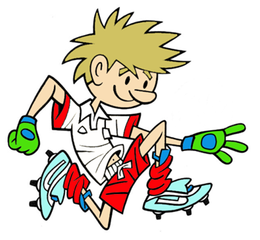

RULES – HOW TO PLAY

Set up course as shown

On whistle, dribble ball around the domes

Stop/trap ball with foot behind the shooting line

Strike for a goal between the target cones

Collect the ball and sprint back through the start line before passing ball onto next player

Score 1 point for successfully dribbling the ball and a further 1 point for scoring a goal

FOCUS
In this activity we are developing the child’s ability to dribble and kick for accuracy
STATION 1: KICKING
Activity: Dribble and Shoot
HARDER
- Make the goals/targets smaller and move further back from the goals
- Use weak foot
- Introduce more obstacle cones

EASIER
- Move shooting line closer to the goals and make the goals wider
- Use a beanbag instead of a football
COACHING POINTS
HEAD
- Head should be over the ball, with eyes fixed on the ball when dribbling and kicking
- Look up now and then to see where you hope to move to next
HANDS
- Arms should be used for the balance when moving and kicking
- Bring arm on kicking side out to the side while the other arm moves out and back behind the body
FEET
- Use the instep and outside of foot to control the ball when dribbling
- Use instep when shooting for control and front of lace for more power when kicking
- Use top of lace for power
EQUIPMENT
- Football x 1

- Domes / Poles x 2

- Target mat / Penalty spot x 1

- Tall cones for goal posts x 2

- Beanbags x 1
Copyright Ulster Council GAA 2009

